Introduction

· Story of Data

· Pre-Analysis

· In-Analysis

· Post-Analysis and Insights

· Recommendations and Observations

· Conclusion
TECHNICAL REPORT ANALYSIS FOR MONSTRA GROUP FOR THE YEAR 2023.
1. Introduction
This report presents a detailed analysis of the sales data of Monstra Group for the year 2023. The analysis aims to provide actionable insights to support strategic decision-making for the upcoming year. The dataset includes Product ID, Sale Date, Sales Rep, Region, Sales Amount, Quantity Sold, Product Category, Unit Cost, Unit Price, Customer Type, Discount, Payment Method, and Sales Channel. The focus is on key performance indicators including sales by sales representative, sales by product category, sales by region, sales by customer type, monthly sales trends, sales by payment method, and sales by sales channel.
2. Story of the Data
The dataset was collected from Kaggle.com. The dataset reflects sales transactions across four regions (North, East, West, South) in 2023, involving five sales representatives (David, Eve, Bob, Alice, Charlie) and four product categories (Clothing, Furniture, Electronics, Food). The total sales amount reaches $5,019,265.23. The data highlights a mix of new and returning customers, with sales distributed across online and retail channels and multiple payment methods (Cash, Credit Card, Bank Transfer).
3. Data Splitting and Preprocessing
- Data Cleaning: The dataset was reviewed for inconsistencies. There was no empty row and empty cells in the dataset.
- Data Segmentation: The data was split by Product ID, Sale Date, Sales Rep, Region, Sales Amount, Quantity Sold, Product Category, Unit Cost, Unit Price, Customer Type, Discount, Payment Method, and Sales Channel
- Data Splitting: The data was divided into Independent and dependent variables. Independent Values in the project are Product ID, Sales Channel, Customer Type, Payment Method, Salesperson, Region, Sales Channel, Product Category
Dependent Values in the project are Sales Date, Unit Cost, Sales Amount, Quantity Sold, Discount, Unit Price .
Industry Context: The Industry is a Grocery store with revenue means.
Stakeholders: The Stakeholder of the data is the Chief Executive Officer.
- Value to The Industry: Generating more revenue. Revenue is the most important factor for the business. This is what they consider as value.

- Pre- Analysis

Potential Analysis/ Questions
Best performing region by revenue generated
Salesperson performance by revenue
Customer performance analysis based on revenue
Customer performance analysis based on quantity purchased
Payment type usage
Best performing goods for the year by quantity
Best performing goods for the year by revenue
Performance analysis for the shipping country.

Fine tune the best region and explore more measures to gain more grounds against the competitors by e.g Advertisement. we can also fine tune the least performing region and implement the measures done in the best performing region e.g Transferring the salesperson from the regions with low sales to ensure the enactment of measures are repeated at the best performing regions.

- In-Analysis

In-Analysis Observations
1. David performed best for the year with a grossing revenue of £1,141,737.36
2. Charlie Performed least for the year with a grossing revenue of £860,811.48
3. January is the best month in the year for revenue generation with a grossing of £495,420.37
5. The North region performed best out of all regions with a revenue generation of £1,369,612.51
6. Clothing is the best performing product with the highest grossing revenue of £1,313,474.36
7. New Customers purchased more items than returning customers
8. Customers purchased more in stores than online
9. Customers purchased more with Credit Cards than cash and bank transfers

In-Analysis Insight
1. Charlie performed least for the year. I do recommend to the stakeholders that Jan should be sent over for some training
2. We could replicate measures implemented in January for months with low sales turn out
3. The North region performed the least for the year. I do recommend to the stakeholders that the management of the North which is the best performing region to be transferred to the South in other to boost sales in the South.
4. I recommend that the stakeholders inform all inventory staff to keep an eye on the clothing stock level in the coming year such that the category does not get low in stock
5. Old customers should be contacted with promotional offers to encourage them to purchase more items

6. Post-Analysis and Insight
- David’s lead in both sales amount and transaction count suggests he is a key asset. Charlie’s lower performance may indicate training needs.
- North’s dominance may reflect better infrastructure or customer density, while South’s lower performance suggests growth potential.
- The near equal split between new and returning customers indicates a healthy market, with opportunities to boost retention through loyalty programs.
- November and October peaks align with holiday shopping, while September’s dip may reflect holiday slowdowns.
- Credit Card and Retail dominance suggest customer preference for secure and in-person transactions, though online growth is notable

7. Data Visualization and Chart

Total Quantity Sold By Salesperson

The Graph above shows that David sold the hight number of product. David sold 222 products.

Salesperson Total Revenue

The Graph above shows that David generated a total revenue of £1,141,737.36

SALES BY PRODUCT CATEGORY

The graph above shows that Clothing generated a total revenue of £1,313,474.36

TOTAL SALES BY REGION

The Chart Above shows that North region generated a total revenue of £1,369,612.51 through sales.

TOTAL REVENUE BY CUSTOMER TYPE

The chart above shows that Returning customers generated the most in revenue with a total of £2,513,006.93

SALES TREND ANALYSIS FOR THE YEAR

The chart above shows the sales trend for the year 2023. Is shows that January is the best month in terms of revenue.

TOTAL REVENUE BY PAYMENT TYPE

The chart above shows that Credit card is the most used method of payment for transactions.

SALES CHANNEL REVENUE

The chart above shows that retail sales brought in more revenue

MONSTRA GROUP DASHBOARD
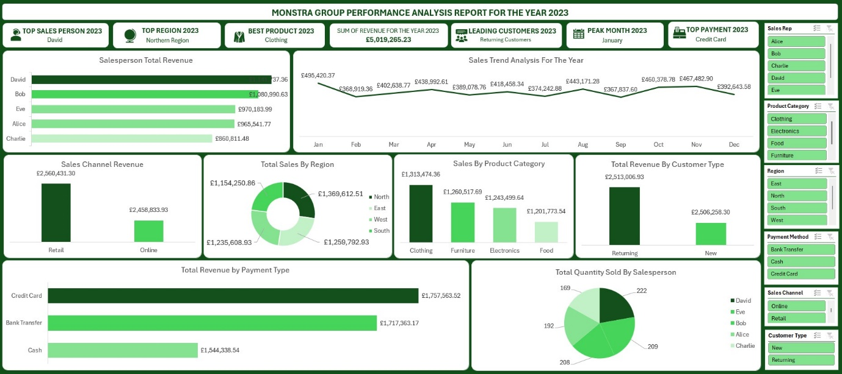
Dashboard of Monstra Group. This dashboard shows the performance analysis report for the year 2023.

8. Recommendation and Observation
Final Observations
Salesperson Observation- Alice
1. Alice had a total sales of £965,541.77.
2. Alice best month in term of revenue generated is November with revenue of £125,488.66
3. Alice sales channel both came from online and retail with revenue of £504,366.15 and £461,205.62
4. Alice sold a total of 192 products
5. Alice highest product sales category was Electronics with a total of £262,316.29
6. Alice generated revenue sales of £485,314.39 from new Customers and £480,227.38 from Returning Customers
7. Bank Transfer was the most used medium of payment
Salesperson Observation- Bob
1. Bob had a total sales of £1,080,990.63
2. Bob best month in term of revenue generated is August with revenue of £129,794.11
3. Bob sales channel both came from online and retail with revenue of £568,188.21 and £512,802.42
4. Bob sold a total of 208 products
5. Bob highest product sales category was Food with a total of £312,988.52
6. Bob generated revenue sales of £523,460.21 from new Customers and £557,530.42 from Returning Customers
7. Bank Transfer was the most used medium of payment
Salesperson Observation- Charlie
1. Charlie had a total sales of £860,811.48
2. Charlie best month in term of revenue generated is April with revenue of £117,609.68
3. Charlie sales channel both came from online and retail with revenue of £447,715.28 and £413,096.20
4. Charlie sold a total of 169 products
5. Charlie highest product sales category was Clothing with a total of £243,329.67
6. Charlie generated revenue sales of £417,616.02 from new Customers and £443,195.46 from Returning Customers
7. Bank Transfer was the most used medium of payment

Salesperson Observation- David
1. David had a total sales of £1,141,737.36
2. David best month in term of revenue generated is October with revenue of £192,511.34
3. David sales channel both came from online and retail with revenue of £576,798.30 and £564,939.06
4. David sold a total of 222 products
5. David highest product sales category was Clothing with a total of £318,184.84
6. David generated revenue sales of £572,138.37 from new Customers and £569,598.99 from Returning Customers
7. Cash was the most used medium of payment
Salesperson Observation- Eve
1. Eve had a total sales of £970,183.99
2. Eve best month in term of revenue generated is January with revenue of £120,821.53
3. Eve sales channel both came from online and retail with revenue of £417,181.78 and £553,002.21
4. Eve sold a total of 209 products
5. Eve highest product sales category was Electronics with a total of £227,780.56
6. Eve generated revenue sales of £507,729.31 from new Customers and £462,454.68 from Returning Customers
7. Credit Card was the most used medium of payment

Final Recommendation
Salesperson Recommendation - Alice
1. Alice should recreate the steps she took in having a good sales month in November and repeat in the months with low sales.
2. Alice could promote the low performing products with incentives to boost the low performing product sales.
3. Alice could also provide incentives to old customers to encourage more purchase.
Salesperson Recommendation- Bob
1. Bob should recreate the steps she took in having a good sales month in August and repeat it in the months with low sales
2. Bob could promote the low performing products with incentives to boost the sales of low performing product.
Salesperson Recommendation- Charlie
1. Charlie should recreate the steps she took in having a good sales month in April and repeat it in the months with low sales
2. Charlie could promote the low performing products with incentives and promotions to boost the low performing product sales.
Salesperson Observation- David
1. David should recreate the steps she took in having a good sales month in October and repeat in the months with low sale
2. David could promote the low performing products with incentives to boost the low performing product sales.
3. David could also provide incentives and promotional offers to old customers to encourage more purchase.

Salesperson Observation- Eve
- Eve should recreate the steps she took in having a good sales month in January and repeat in the months with low sale
- Eve could promote the low performing products with incentives to boost the low performing product sales.
- Eve could also provide incentives and promotional offers to old customers to encourage more purchase.

9. Conclusion
The 2023 sales data analysis reveals a robust revenue stream, with significant opportunities for strategic growth. By leveraging insights on top customers, regional disparities, product popularity, and seasonal trends, management can maximize resource allocation and marketing efforts. Addressing data gaps will further enhance decision making, positioning the company for a successful 2024.

10. References & Appendices
Pivot table summaries and raw data provided in the document from Keggle.com.

